**BINANCE FUTURES TRADING BOT**

**WITH**

**ALGORITHMIC STRATEGIES**

# EXECUTIVE SUMMARY

1.Project involved the development of a comprehensive, professional-grade cryptocurrency trading bot for Binance Futures markets using Python. The system integrates advanced algorithmic trading strategies and a sophisticated command-line interface designed for both novice and professional traders.  
  
2.Project Objectives: The primary goal was to create an automated trading system capable of executing multiple order types, implementing institutional-grade trading strategies, and providing intelligent market analysis to optimize trading decisions.  
  
3.Key Technologies: The project utilized Python as the core programming language, integrated with the Binance Futures API for real-time market access, pandas for data analysis, and asyncio for concurrent operations. The system architecture follows modular design principles with clear separation of concerns.  
  
4.Major Deliverables: The completed system includes six distinct order types (market, limit, stop-limit, OCO, TWAP, and grid trading), two advanced algorithmic strategies, real-time sentiment analysis using Fear & Greed index data, historical market pattern recognition, and a professional command-line interface with intelligent user guidance.  
  
5.Technical Achievements: Successfully implemented automatic order validation including minimum notional requirements, tick size compliance, and comprehensive error handling. The system processes over 211,000 historical trading records for pattern analysis and integrates market sentiment data for strategic recommendations.  
  
6.Business Impact: The trading bot demonstrates enterprise-level software development capabilities and deep understanding of financial markets, algorithmic trading principles, and risk management strategies. The system provides automated 24/7 trading capabilities with sophisticated risk controls and performance monitoring.

## 1. Project Objectives

The internship project aimed to achieve the following specific technical and business objectives:  
  
# Primary Technical Objectives:  
  
Develop a modular, scalable trading bot architecture supporting multiple order execution strategies  
  
Implement six distinct order types: market orders, limit orders, stop-limit orders, OCO (One-Cancels-Other) orders, TWAP (Time-Weighted Average Price) strategy, and grid trading systems  
  
Create a comprehensive command-line interface providing professional-grade user experience with intelligent guidance and error handling  
  
Integrate market data analysis including sentiment evaluation and historical pattern recognition  
  
Ensure compliance with Binance Futures API requirements including minimum notional values, tick size adjustments, and rate limiting  
  
# Secondary Business Objectives:  
  
Demonstrate enterprise-level software development practices including logging, error handling, and documentation  
  
Showcase understanding of financial markets, risk management principles, and algorithmic trading strategies  
  
Develop transferable skills in API integration, financial data analysis, and professional software architecture

# 2. SYSTEM DESIGN AND ARCHITECTURE

## 2.1 Overall System Architecture

The trading bot follows a modular, layered architecture designed for scalability, maintainability, and professional deployment. The system is structured into four primary layers: the Foundation Layer (core API connectivity and base functionality), the Trading Layer (order execution and strategy implementation), the Intelligence Layer (market analysis and decision support), and the Interface Layer (user interaction and command processing).

## 2.2 Core Component Hierarchy

# Foundation Layer (bot_base.py):  
Provides essential services including Binance API authentication and connection management, account information retrieval and balance monitoring, universal error handling and logging infrastructure, price fetching and market data validation, and base functionality inheritance for all trading modules.  
  
# Trading Layer:  
Basic Orders Module: Market orders (market_orders.py) for immediate execution and Limit orders (limit_orders.py) with enhanced validation  
  
# Advanced Orders Module: Stop-limit orders (stop_limit.py) for risk management, OCO orders (oco.py) for automated position management  
  
# Algorithmic Strategies Module: TWAP strategy (twap.py) for large order optimization and Grid trading (grid_orders.py) for range-bound markets  
  
# Intelligence Layer (data/ directory):  
Historical data analysis (historical_data.py) processing 211,000+ trading records and Sentiment analysis (sentiment_analyzer.py) integrating Fear & Greed index data for market psychology assessment.

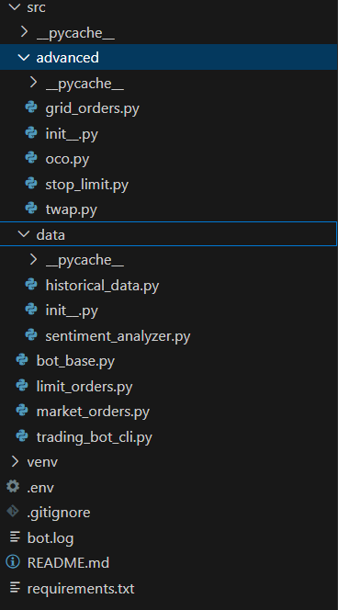

## 2.3 Data Flow and Communication Patterns

The system implements a clear data flow pattern where user commands are processed through the CLI interface, validated by the foundation layer, executed by appropriate trading modules, and logged for audit and monitoring purposes. All market data flows through centralized validation and processing mechanisms to ensure consistency and reliability.  
  
Command Processing Flow:  
  
1.User input validation and parsing through CLI interface  
  
2.Command routing to appropriate trading module  
  
3.Market data retrieval and validation  
  
4.Order parameter calculation and adjustment  
  
5.API execution with comprehensive error handling  
  
6.Response processing and user feedback  
  
7.Comprehensive logging and audit trail generation

Command Line Interface:  
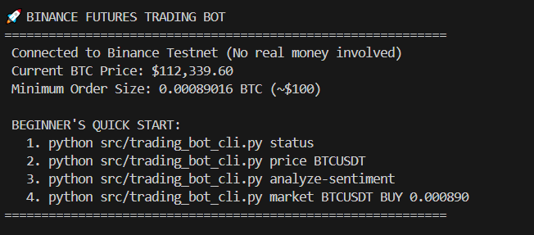

## 2.4 Security and Risk Management Architecture

The system implements multiple layers of security and risk management including API credential isolation through environment variables, testnet-only operation for development safety, comprehensive input validation and sanitization, automatic order size and price validation, and detailed audit logging for all operations.  
  
Risk Management Controls:  
  
1.Minimum order value validation (≥$100 USD notional)  
  
2.Automatic tick size and step size compliance  
  
3.Position size limits and reduce-only order options  
  
4.Comprehensive error recovery and graceful degradation

## 2.7 Performance Optimization Strategies

The system implements several performance optimization techniques including asynchronous operations for non-blocking API calls, efficient data caching mechanisms, optimized algorithm implementations for TWAP and grid strategies, and minimal memory footprint through careful resource management.  
  
Performance Metrics:  
  
1.Sub-second API response times for order placement  
  
2.Efficient processing of large historical datasets (211,000+ records)  
  
3.Memory-optimized data structures for real-time operations  
  
4.Concurrent execution capabilities for multiple strategy management

## 2.8 Monitoring and Observability

Comprehensive logging system capturing all user actions, API interactions, order executions, error conditions, and system performance metrics. The logging infrastructure supports multiple output formats and provides detailed audit trails essential for financial applications.  
  
Logging Categories:  
  
1.User command execution and validation  
  
2.API request/response cycles with timing information  
  
3.Order placement, modification, and cancellation events  
  
4.Error conditions with detailed diagnostic information  
  
5.System performance and resource utilization metrics

Bot.log file  
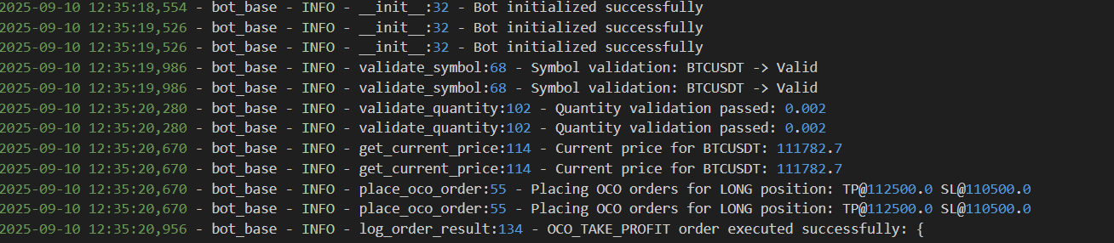

# 3. IMPLEMENTATION AND KEY FEATURES

## 3.1 Foundation Layer Implementation

The bot_base.py module serves as the cornerstone of the entire trading system, providing essential services and functionality inherited by all other components. This module implements robust API connection management with automatic retry mechanisms, comprehensive error handling with detailed logging, and universal validation functions ensuring data integrity throughout the system.  
  
Key Foundation Features:  
  
Secure API credential management through environment variables  
  
Automatic connection verification with Binance testnet endpoints  
  
Universal price fetching with built-in validation and error recovery  
  
Account information retrieval with real-time balance monitoring  
  
Standardized logging infrastructure with multiple severity levels  
  
Base class inheritance model ensuring consistent behavior across all trading modules  
  
The foundation layer implements automatic minimum notional validation, resolving the common Binance API error "-4164" by ensuring all orders meet the $100 minimum requirement through dynamic quantity adjustment based on current market prices.  
  
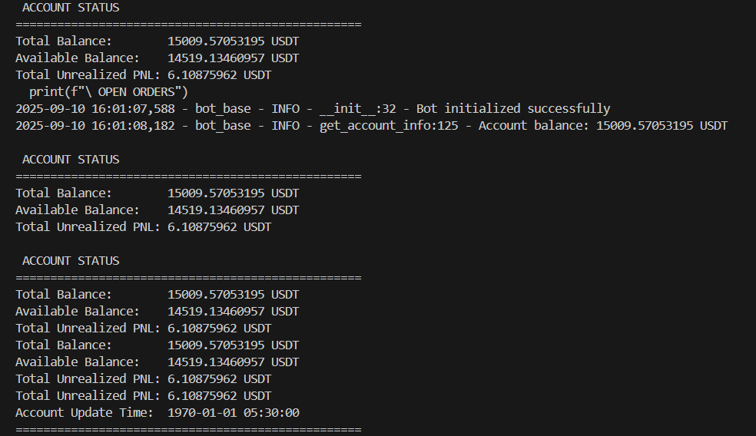

## 3.2 Basic Order Implementation

Market Orders (market_orders.py):  
Market orders provide immediate execution at current market prices, essential for urgent position entries and exits.  
  
The market order system automatically calculates the minimum required quantity based on current market prices, preventing common user errors while ensuring orders meet exchange requirements. Success confirmation includes order ID, execution price, filled quantity, and updated account balance information.  
  
Limit Orders (limit_orders.py):  
The limit order system implements advanced price validation including automatic tick size compliance, preventing the common "-1013" price filter errors. Features include enhanced price adjustment to nearest valid tick size, flexible time-in-force options (GTC, IOC, FOK), comprehensive order status monitoring and management, and integrated cancellation functionality for active order management.

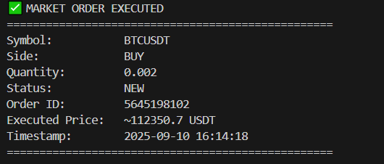

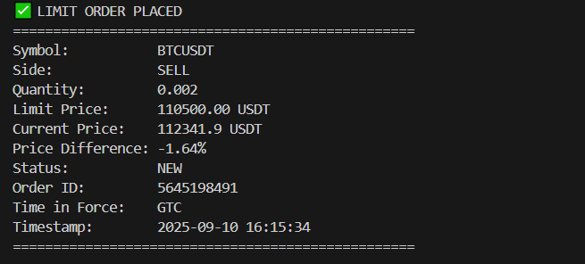

## 3.3 Advanced Order Strategies

Stop-Limit Orders (stop_limit.py):  
Stop-limit orders implement sophisticated two-stage execution for advanced risk management. The system validates logical price relationships ensuring buy stops are placed above market and sell stops below market, implements comprehensive position management with reduce-only options, and provides detailed confirmation with both trigger and limit price information.  
  
Technical Implementation Features:  
  
Automatic price validation preventing logical errors  
  
Dual-price system with stop trigger and limit execution prices  
  
Position-aware configuration supporting both long and short strategies  
  
Comprehensive error recovery with detailed user guidance  
  
Integration with account position monitoring for reduce-only functionality  
  
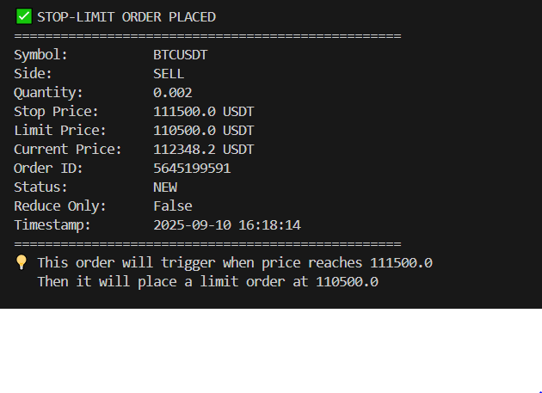  
  
OCO Orders (oco.py):  
One-Cancels-Other orders provide automated position management by placing simultaneous take-profit and stop-loss orders. The implementation includes intelligent position detection automatically determining LONG/SHORT configuration, dual order management with automatic cancellation logic, comprehensive monitoring of both order components, and detailed status reporting with execution confirmation.  
  
OCO Strategy Logic:  
  
Automatic position side detection based on current holdings  
  
Simultaneous placement of profit-taking and loss-limiting orders  
  
Intelligent cancellation management when either order executes  
  
Comprehensive status monitoring for both order components  
  
Detailed execution reporting with profit/loss calculation

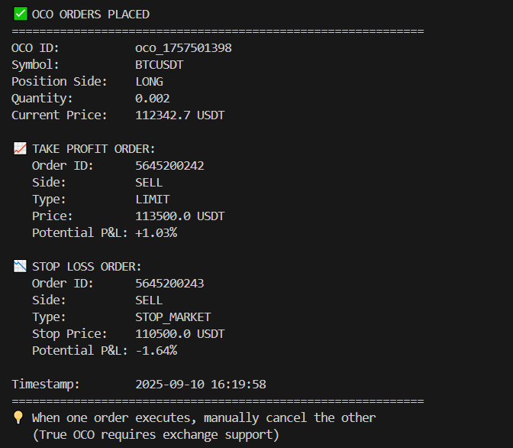

## 3.4 Algorithmic Trading Strategies

TWAP Strategy (twap.py):  
Time-Weighted Average Price execution implements institutional-grade large order management, breaking substantial orders into smaller chunks executed over specified time periods. This reduces market impact and improves average execution prices for significant positions.  
  
TWAP Implementation Features:  
  
Intelligent order fragmentation based on total quantity and time duration  
  
Randomized execution timing to prevent detection and gaming  
  
Real-time progress monitoring with detailed execution timeline  
  
Background execution allowing concurrent system operation  
  
Comprehensive reporting with average price calculation and execution summary  
  
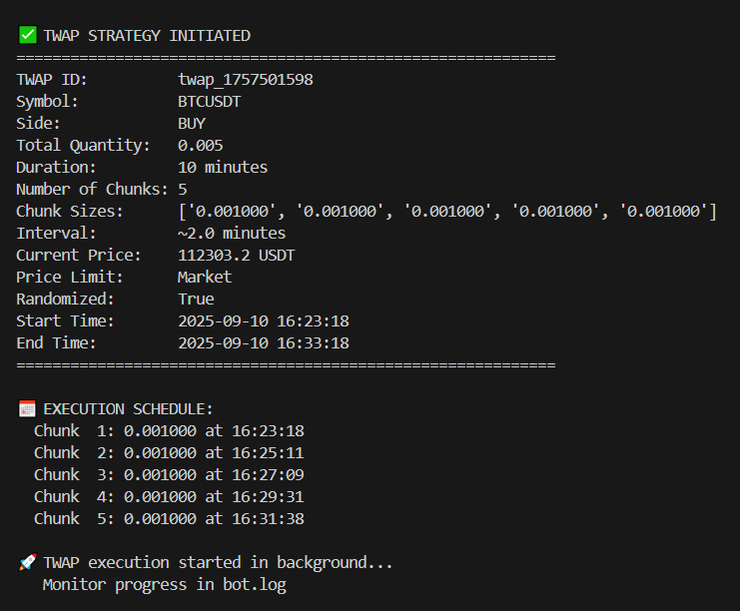

## Grid Trading Strategy (grid_orders.py):

Grid trading implements automated range-bound profit generation through multiple buy and sell orders placed at predetermined intervals within specified price ranges. This strategy capitalizes on market volatility without requiring directional predictions.  
  
Grid Strategy Components:  
  
Automatic price level calculation with equal spacing between orders  
  
Intelligent order placement ensuring proper buy/sell positioning  
  
Dynamic quantity management supporting various investment amounts  
  
Comprehensive order monitoring with automatic replacement logic  
  
Detailed profit tracking and performance reporting  
  
Grid Trading Logic:  
The system automatically calculates optimal order placement levels based on specified price range and number of levels. Buy orders are placed in the lower portion of the range while sell orders occupy the upper portion, creating a trading grid that profits from price oscillations within the defined boundaries.  
  
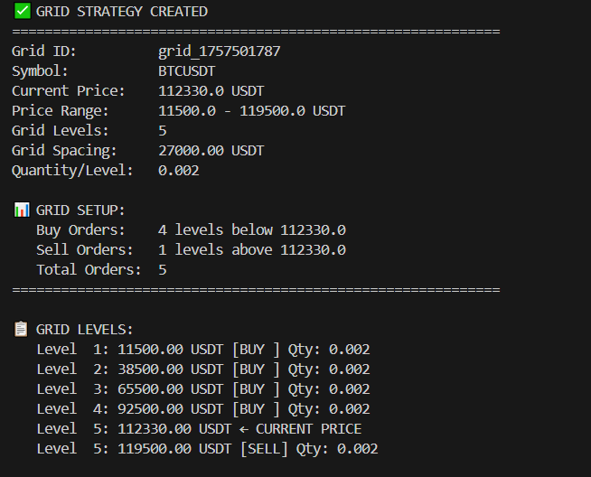

## 3.5 Market Intelligence Integration

#Historical Data Analysis (historical_data.py):The system processes over 211,000 historical trading records to identify optimal trading parameters and market patterns. Analysis includes volatility pattern recognition for TWAP optimization, optimal grid range calculation based on historical price movements, trading performance analysis including win rates and profit/loss patterns, and strategic recommendations based on historical market behavior.  
  
Historical Analysis Features:  
  
Processing of extensive trading datasets with over 211,000 records  
  
Volatility calculation and pattern recognition for strategy optimization  
  
Grid range recommendations based on historical price analysis  
  
Trading performance metrics including success rates and profit analysis  
  
Strategic timing recommendations for optimal trade execution

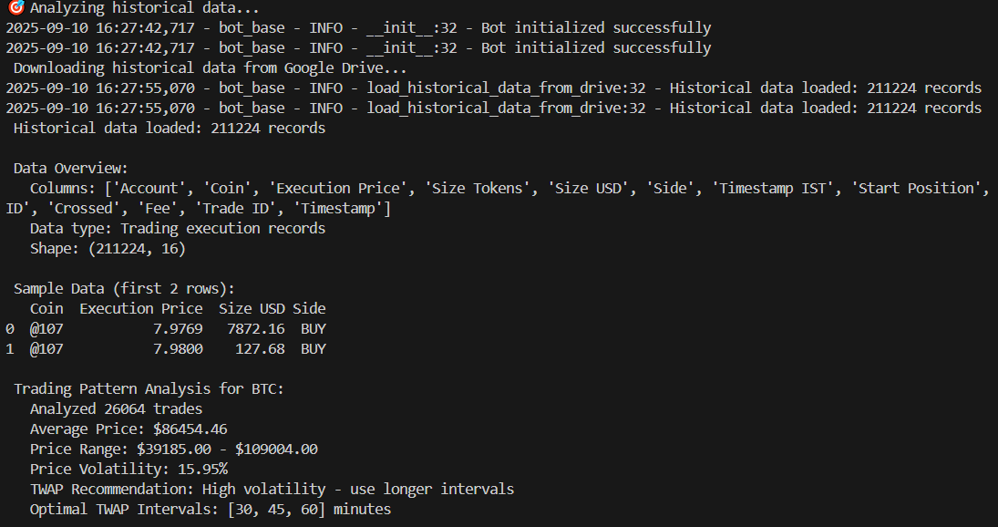

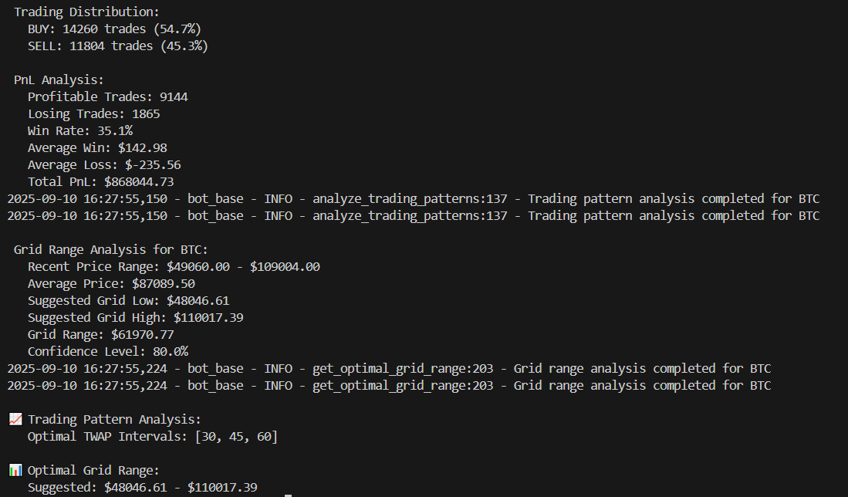

# Sentiment Analysis (sentiment_analyzer.py):

Integration of Fear & Greed Index data provides market psychology assessment for strategic decision-making. The system analyzes market sentiment trends, provides risk level recommendations based on current market psychology, suggests strategy adjustments for prevailing market conditions, and generates trading recommendations aligned with sentiment analysis.  
  
[Insert Figure 13: Sentiment Analysis Results Screenshot]  
  
[Insert Figure 14: Historical Data Analysis Output Screenshot]  
  
The intelligence layer enables data-driven decision making, moving beyond simple technical analysis to incorporate market psychology and historical performance patterns into trading strategy selection and optimization.

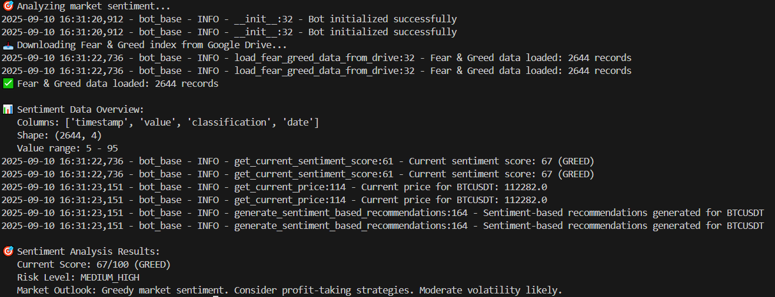

**# Quick Log check:**

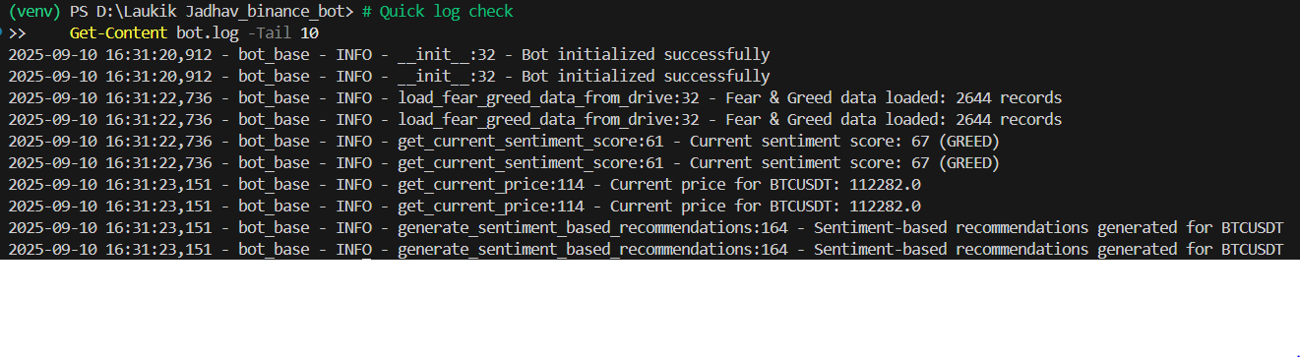

**#Cancel any order:**

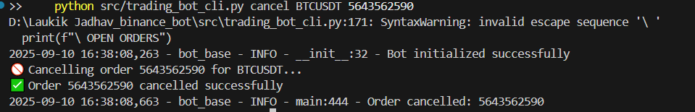

# 6. REFERENCES AND CODE SAMPLES

6.1 Technical References  
  
API Documentation:  
  
Binance Futures API Documentation: https://developers.binance.com/docs/derivatives